

Student Name……………………………………

FURTHER MATHEMATICS

TRIAL EXAMINATION 1

(FACTS, SKILLS AND APPLICATIONS)

2002

Reading Time: 15 minutes
Writing time: 90 minutes

Instructions to students
This exam consists of Section A and Section B.
Section A contains 13 multiple-choice questions from the core, “Data Analysis”.
Section A is compulsory and is worth 13 marks.
Section B consists of 5 modules each containing 9 multiple-choice questions. You should choose 3 of these modules and answer every question in each of your chosen modules.
Each of the modules is worth 9 marks.
Section B begins on page 10 of this exam.
There is a total of 40 marks available for this exam.
Students may bring up to two A4 pages of pre-written notes into the exam.
An answer sheet appears on page 37 of this exam.
Formula sheets can be found on pages 35 and 36 of this exam.

This paper has been prepared independently of the Victorian Curriculum and Assessment Authority to provide additional exam preparation for students. Although references have been reproduced with permission of the Victorian Curriculum and Assessment Authority, the publication is in no way connected with or endorsed by the Victorian Curriculum and Assessment Authority.

© THE HEFFERNAN GROUP 2002
This Trial Exam is licensed on a non transferable basis to the purchaser. It may be copied for educational use within the school which has purchased it. This license does not permit distribution or copying of this Trial Exam outside that school or by any individual purchaser.
Section A

Core

All questions must be answered.

The following information relates to questions 1, 2, 3 and 4.

The ordered, back-to-back stemplot below shows the distribution of the handspan (in cm) of two groups of students, one a group of 18 Prep students and the other a group of 20 Year 3 students.

Handspan
Prep (n = 18) Year 3 (n = 20)

 |  |  |  | 8 | 5 | 14
 | 7 | 2 | 2 | 1 | 0 | 15 | 9
9 | 8 | 5 | 3 | 3 | 2 | 16 | 2 | 7
 |  |  | 5 | 5 | 1 | 17 | 0 | 1 | 1 | 2
 |  |  |  | 4 | 2 | 18 | 1 | 2 | 3 | 3 | 6 | 7 | 8
 |  |  |  |  |  | 19 | 1 | 3 | 4 | 6
 |  |  |  |  |  | 20 | 3
 |  |  |  |  |  | 21 | 2

Question 1

The standard deviation of the Prep student’s measurements is closest to

- 2.68
- 11.45
- 11.78
- 260.19
- 267.74

Question 2

The interquartile range of the distribution of handspans for the 20 Year 3 students is

- 14
- 21
- 21.5
- 25
- 28

Question 3

The percentage of Year 3 children in this group with a handspan of less than 170cm is

- 3%
- 15%
- 20%
- 25%
- 72%
Question 4

Compared to the distribution of the Prep students, the distribution of the handspans of the Year 3 students

- is less variable
- has more outliers
- is more skewed
- has a higher centre
- is more symmetrical

Question 5

The distribution of the weight of half-kilogram packets of flour is bell-shaped with a mean of 500g and a standard deviation of 15g.
The percentage of packets with a weight of less than 470g is

- 0.3%
- 2.5%
- 5%
- 16%
- 32%

The following information relates to Questions 6, 7 and 8.

The scatterplot below shows the number of tracks and the corresponding duration (in minutes) of 6 popular music CD’s.

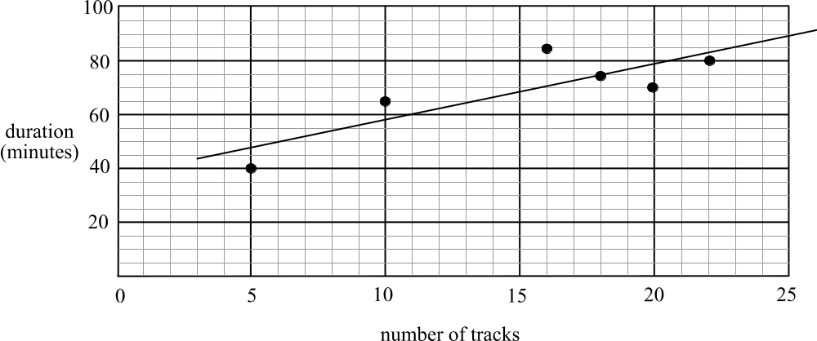

A least squares regression line has been fitted to the data. The equation of this line is given by the following eqution.
.

Question 6

Using this equation, we would expect that if a popular music CD had 30 tracks, then it would have a duration of

- 61.20 minutes
- 78.01 minutes
- 99.44 minutes
- 139.21 minutes
- 1149.24 minutes

Question 7

The slope of the least squares regression line is given by 2.04. This tells us the

- intercept with the vertical axis
- extrapolated value of the duration of the CD
- interpolated value of the number of tracks
- average duration of a CD
- average duration of a track
Question 8

The corresponding residual plot for this least squares regression line could be

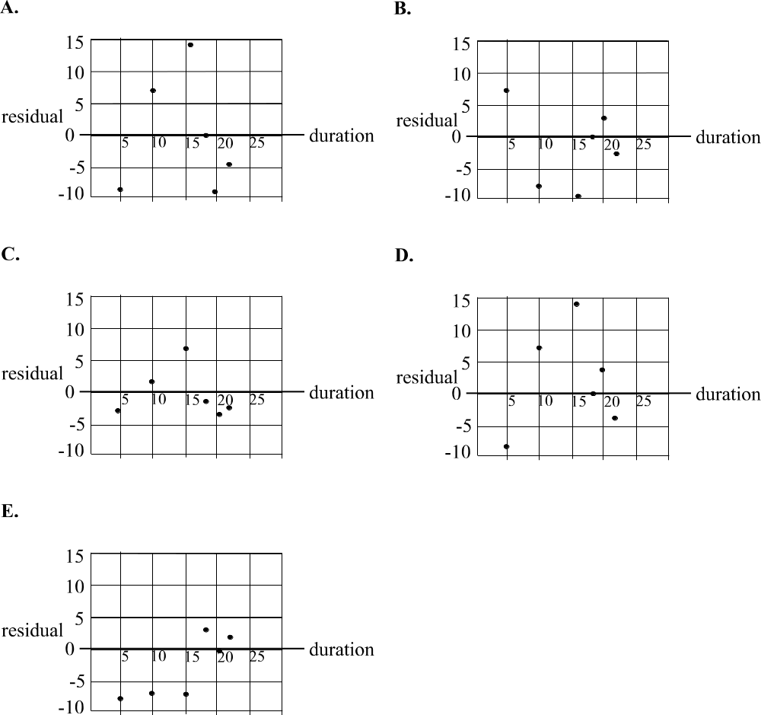

Question 9

The data shown in the scatterplot below has a three median line fitted to it.

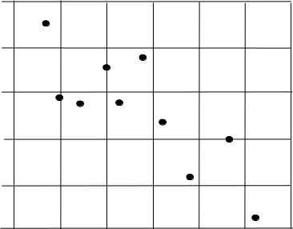

Which one of the following shows the correct three median line?

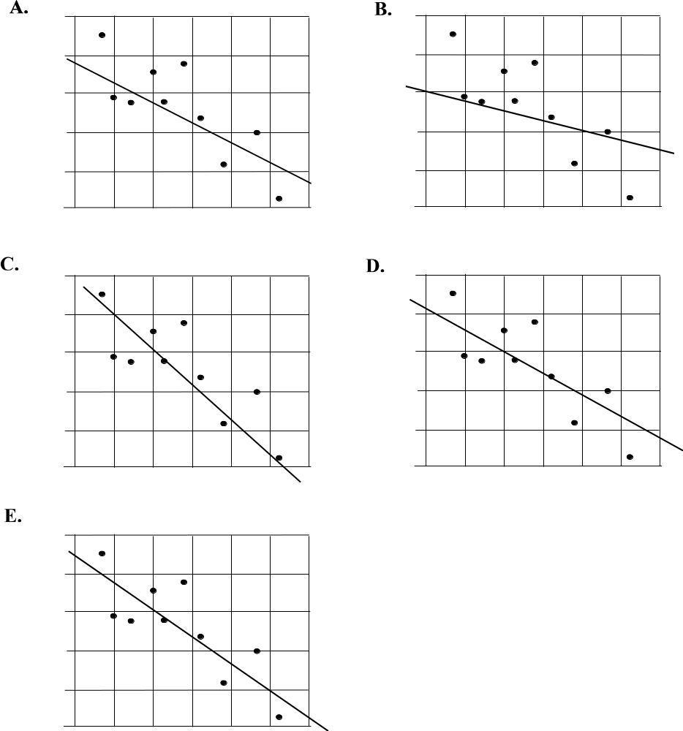

Question 10

Steve has been advised correctly to try using a 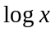 transformation or a 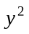transformation to try to linearise some data he has in front of him on a scatterplot.
Which one of the following is the scatterplot that Steve could have in front of him?

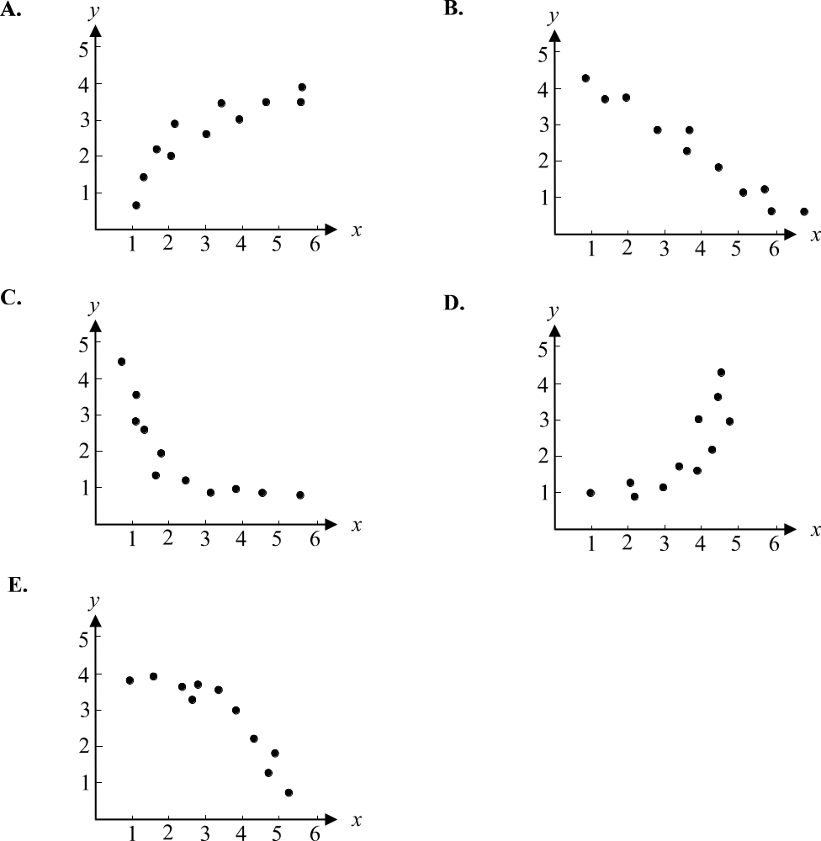

Question 11

The time series plot below shows the number of visitors at a wildlife park over the past 5 years.

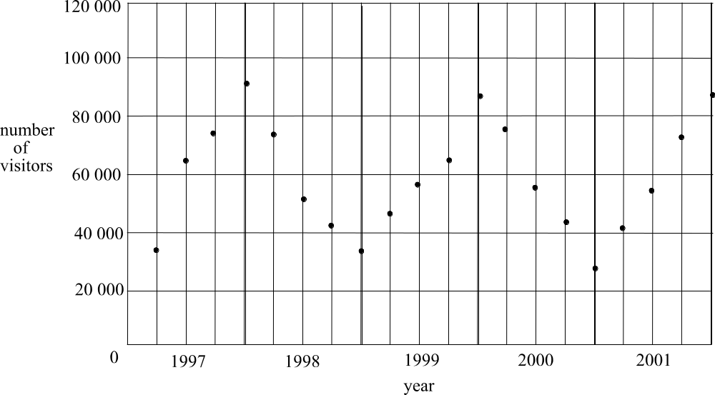

The number of visitors at this wildlife park over the past 5 years, according to this plot, can best be described as

- trending downwards
- random
- seasonal and trending upwards
- cyclic
- cyclic and trending upwards

Question 12

Two of the seasonal indices used to deseasonalise tyre sales at Big Joe’s tyre company are shown below.

summer | autumn | winter | spring
0.84 |  | 1.31

The seasonal indices for autumn and spring respectively could be

- 0.92 and 0.93
- 0.84 and 1.31
- 1.08 and 1.07
- 0.79 and 0.93
- 1 and 2.11
Question 13

The number of people attending a fundraising meeting at the local school each month is shown in the table below.

Month | Number attending
February | 22
March | 19
April | 20
May | 16
June | 12
July | 18
August | 18
September | 16
October | 15
November | 17

Using a five point moving average, the smoothed value of the number of people attending the meeting in May is

- 14
- 15
- 16
- 17
- 18

Section B

Section B consists of 5 modules and each module contains 9 questions. You should select 3 modules only and answer all questions in each of these modules.

Module 1: Number patterns and applications

If you choose this module all questions must be answered.

Question 1

Which one of the following is an arithmetic sequence?

- 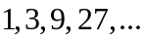
- 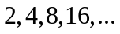
- 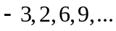
- 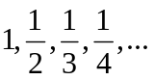
- 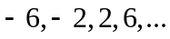

Question 2

The third term of an arithmetic sequence is 8 and the fifth term is 14. The first term of this sequence is

- –4
- –1
- 2
- 3
- 5

Question 3

The sum of the infinite geometric sequence
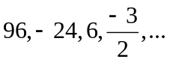
is

- 19.2
- 32
- 54
- 76.8
- 128
Question 4

Thirty-five percent of a new brand of cereal is made up of dried fruit. The ratio of dried fruit to other ingredients in each packet of this cereal is

- 7:13
- 7:20
- 13:7
- 13:20
- 20:7

Question 5

The difference equation 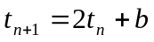 where 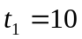generates the sequence 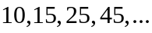
The value of b is

- –10
- –5
- 5
- 10
- 15

Question 6

The sequence, which is generated by the difference equation
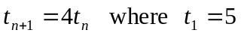
could also be generated by the geometric sequence with rule

- 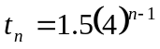
- 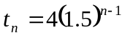
- 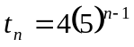
- 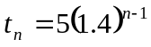
- 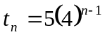

Question 7

George invested $2500 at the start of the year in a superannuation fund and added $500 to the investment during each year. The amount, 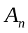, that he had invested in the fund at the end of the nth year, decreased by 3% each year. A difference equation that could model this situation is

- 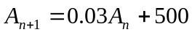
- 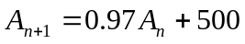
- 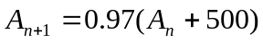
- 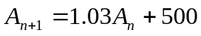
- 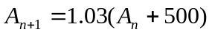

Question 8

To use up some old paint, Con mixed 2 litres of old pink paint with 10 litres of new white paint. To complete the job however, Con needs an extra 4 litres of the exact shade that he has created. How many litres of the old pink paint will he require?

- 
- 
- 
- 

Question 9

A company manufactured 12 solar powered cars in its first year of operation. If the number of cars produced by the factory increases by 20% each year, during which year of operation will the company manufacture the 100th solar powered car?

- 5th
- 6th
- 9th
- 10th
- 13th

Module 2: Geometry and trigonometry

If you choose this module all questions must be answered.

Question 1
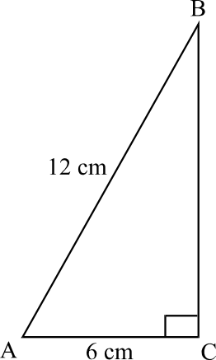

In 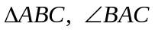 is closest to

- 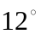
- 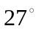
- 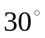
- 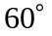

Question 2

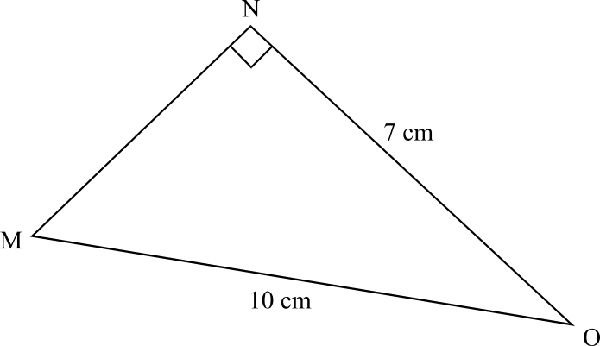

In 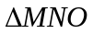, the length of MN is closest to

- 3cm
- 5cm
- 7cm
- 9cm
- 12cm
Question 3
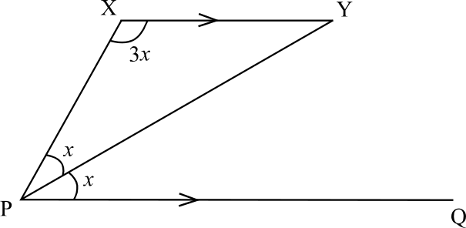

In the diagram, XY is parallel to PQ. In 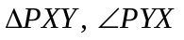 is equal to

- 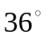
- 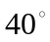
- 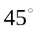
- 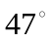

Question 4
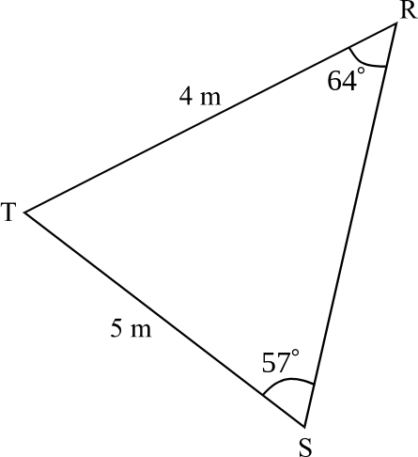

The area of 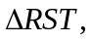 correct to 2 decimal places is

- 8.39 square metres
- 8.57 square metres
- 8.99 square metres
- 10.00 square metres
- 17.14 square metres

Question 5

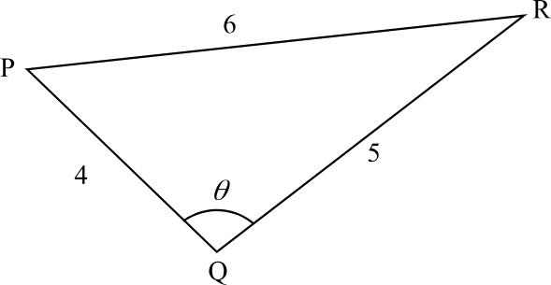

In 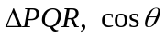 equals

- 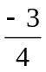
- 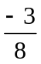

Question 6
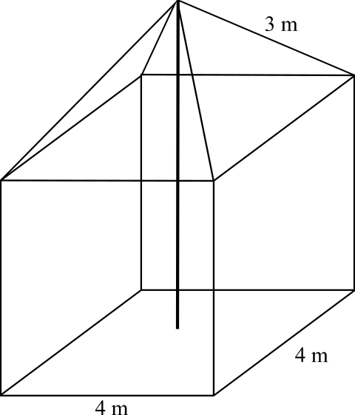

A tent is in the shape of a cube of sidelength 4 metres, with a right pyramid on top. The slant edges of this pyramid are 3m long. A vertical pole supporting the tent has its base in the centre of the floor of the tent. The height of the pole is

- 4.8m
- 5m
- 6.2m
- 9m
- 9.6m

Question 7
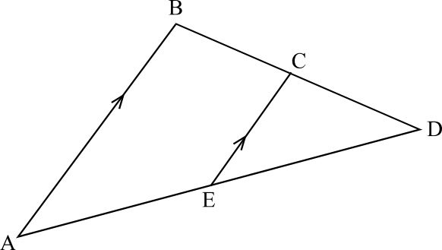

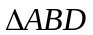 is similar to 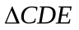.
The ratio of CE to AB is 4:9.
The area of 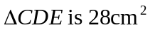.
The area of 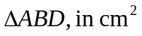, is

- 36
- 63
- 90.72
- 141.75
- 343
Question 8

A group of walkers set off from a carpark and walk to a hut on a bearing of 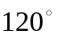. After resting at the hut they then walk on a bearing of 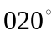for a distance of 5km, which brings them to a campsite, which is located due east of the carpark.
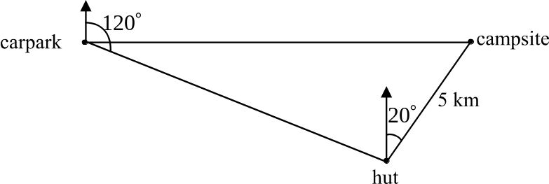

The distance from the carpark to the campsite is closest to

- 8.9km
- 9.4km
- 9.8km
- 12.6km
- 16.8km

Question 9

Part of a field sketch from a traverse survey is shown in the diagram below.
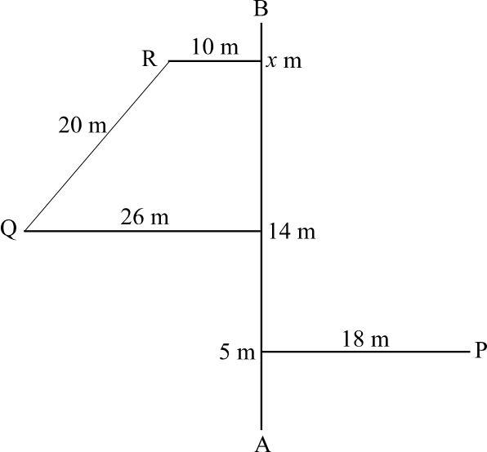

The measurements beside the three points of intersection on the base line AB indicate the distance from point A. The perpendicular offset distances of the points of interest at P, Q and R are shown on the diagram. It is known that distance QR is 20 metres.
The value of x is

- 19
- 20
- 24
- 26
- 34
Module 3: Graphs and relations

If you choose this module all questions must be answered.

Question 1

The temperature, in degrees Celsius, in a controlled environment, is monitored over a 15 minute period and is shown in the graph below.

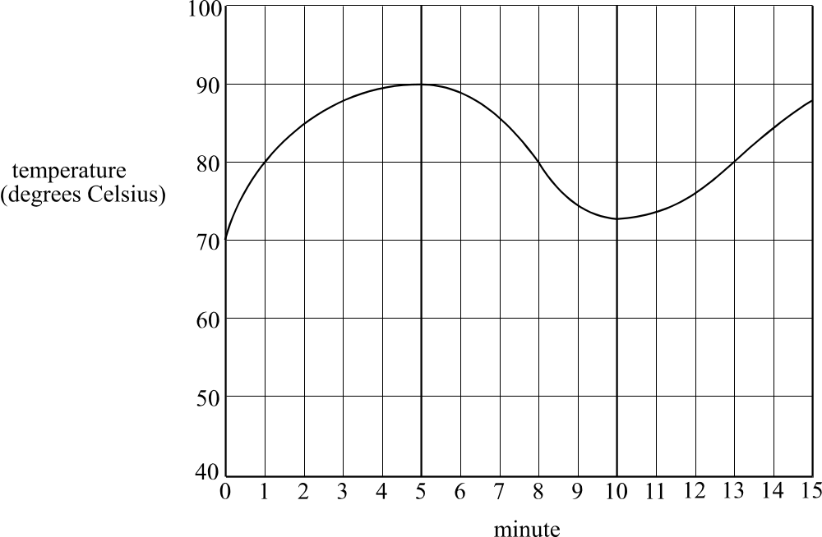

During the 15 minute period, temperature was below 80 degrees Celsius for a total of

- 5 minutes
- 6 minutes
- 7 minutes
- 9 minutes
- 15 minutes

Question 2

The equation 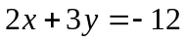 has a graph given by

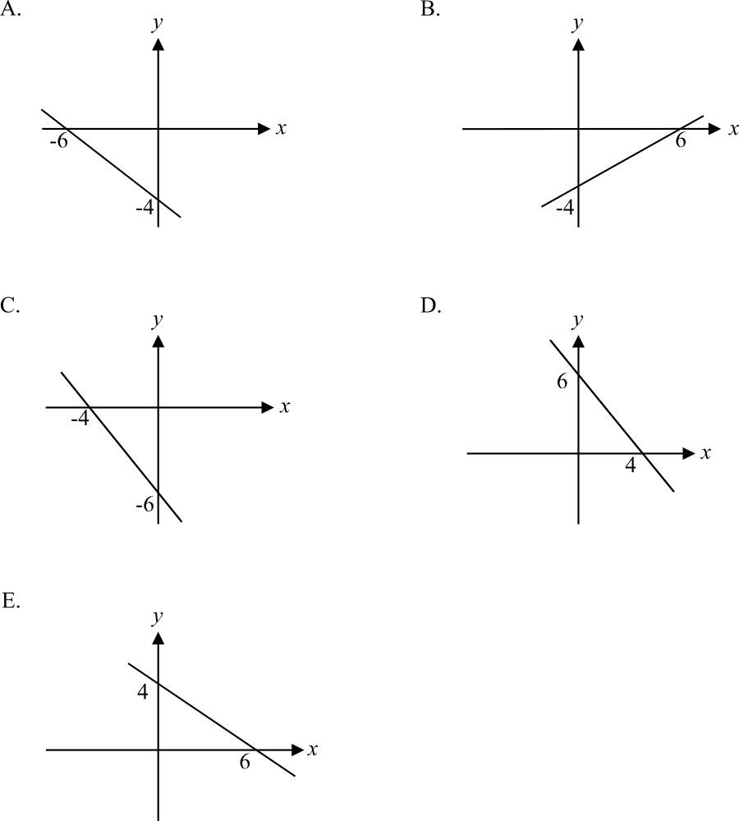

Question 3

The cost of buying a particular stock on the stock market is shown over a 4 hour period one Friday on the graph below.

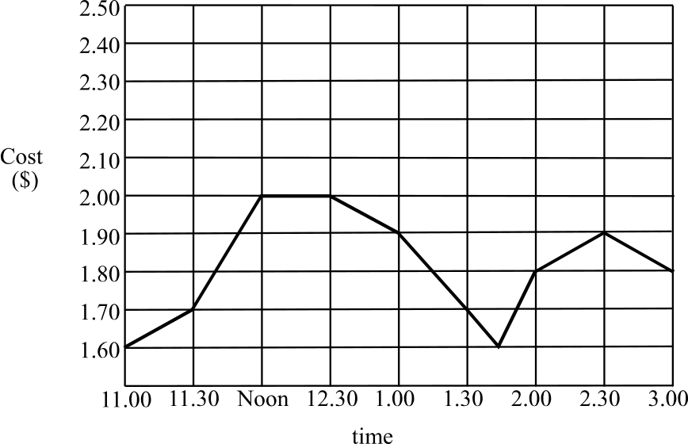

Which one of the following statements is not true?

The cost of the stock during this 4 hour period

- increased most rapidly between 1.45 and 2pm.
- reached a maximum of $2.00.
- finished higher than it started.
- decreased most rapidly between 2.30 and 3pm.
- reached a minimum of $1.60.

The following information relates to Questions 4 and 5.

The feasible region in a linear programming problem is indicated by the shaded area on the graph below.

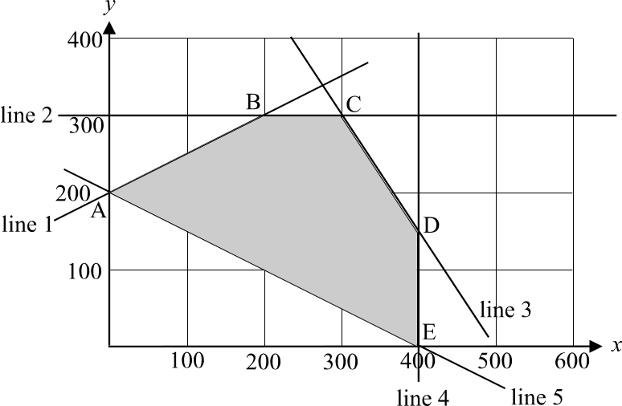

The lines which form the feasible region are labelled as line 1, line 2, and so on. The corner points of the feasible region are labelled as points A, B, C, D and E.

Question 4

Which line has the equation 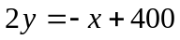?

- line 1
- line 2
- line 3
- line 4
- line 5

Question 5

The objective function is given by 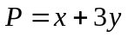. The maximum value of P for the feasible region occurs at point

- A
- B
- C
- D
- E

Question 6

The cost of a particular type of document wallet varies according to the number of wallets being purchased. The graph below shows the relationship between the number of document wallets being purchased and the cost.

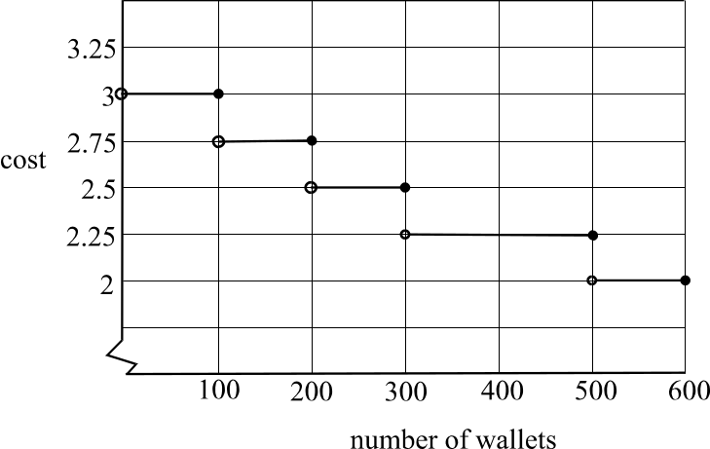

On Tuesday there were 3 sales of this style of document wallet. One customer bought 150 of the document wallets, another bought 300 and the third customer bought 600. What was the total amount spent by these 3 customers on these wallets on Tuesday?

- $2250
- $2287.50
- $2150.50
- $2362.50
- $2400

The information below relates to questions 7 and 8.

A catering firm offers two packages, Package 1 and Package 2, to its corporate clients for in-house lunches. Package 1 has a fixed cost of $100 and a cost of $10 for every person attending the lunch.
The graph showing the cost, C, of the packages against the number, n, attending a lunch is shown below.

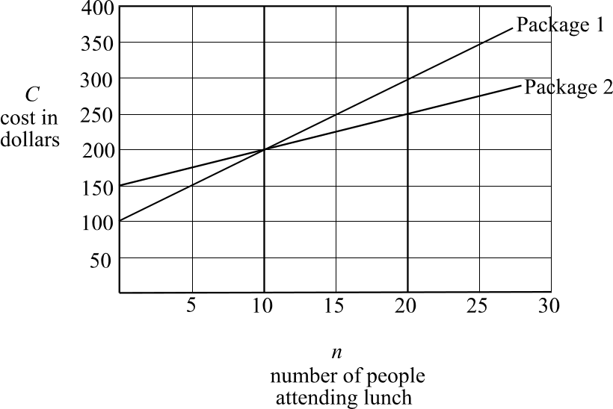

Question 7

The equation, which relates n and C for Package 1, is

- 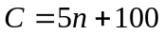
- 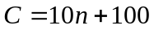
- 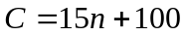
- 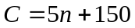
- 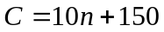

Question 8

When there are 10 people attending a lunch, the difference in cost between Package 1 and Package 2 is

- $0
- $10
- $50
- $100
- $200
Question 9

The graph given in Figure A below shows the relationship 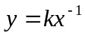.

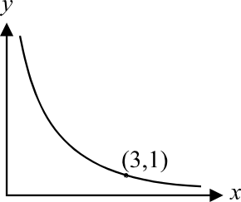

Figure A

The graph given in Figure B below has y plotted against 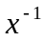 and shows the same relationship.
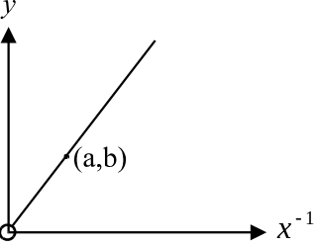

Figure B

The point  could be the point

- 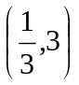
- 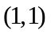
- 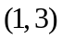
- 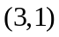
- 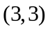

Module 4: Business-related mathematics

If you choose this module, all questions must be answered.

Question 1

Paul invested $8000 in an account attracting simple interest of 4.5% per annum. Over the period of the investment Paul earned a total of $1080 in interest. For how many years did Paul have this money invested?
- 1.6
- 2.4
- 3
- 6
- 7.4

Question 2

Sally invests $12 000 at 6% per annum interest compounding monthly. After 4 years this investment is worth

- $12 241.81
- $14 586.08
- $15 149.72
- $15 245.87
- $124 815.24

Question 3

Sound equipment in a studio depreciates at the rate of 22% per year. The equipment was purchased for $270 000. How much was it worth 3 years after purchase?

- $128 129.04
- $154 262.38
- $164 268.00
- $183 997.44
- $210 600.00

Question 4

The last 5 transactions in Lou’s account are shown below.

Date | Credit | Debit | Interest | Balance
07April02 | $400.00 |  |  | $1247.00
01May02 |  |  | $3 | $1250.00
04May02 |  | $250.00 |  | $1000.00
11May02 | $500.00 |  |  | $1500.00
01June02 |  |  | $2 | $1502.00

Simple interest is calculated on the minimum monthly balance and is paid into the account on the first day of each month. The annual rate of interest paid is
- 0.16%
- 0.2%
- 1.6%
- 2%
- 2.4%
Question 5

A photocopy machine was bought for $18500 and depreciates at the rate of 12 cents for every 1000 copies made. A company trades in the machine when it reaches a book value of $5000. How many copies can be made before the machine is traded?

- 112 500
- 154 167
- 1 125 000
- 112 500 000
- 1 779 166 667

Question 6

Brian takes out a reducing balance loan of $15000 at a compound interest rate of 6% per annum. Brian makes repayments at regular intervals of $500.
The amount that Brian owes on this loan after 4 years can be calculated using the annuity formula. The calculation is
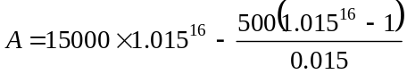
How often does Brian make his regular repayments?

- weekly
- monthly
- quarterly
- 6 monthly
- annually
Question 7

The production of metal components produced by the company Metals Inc. is increasing by 5.8% per year.

A graph showing this production could be

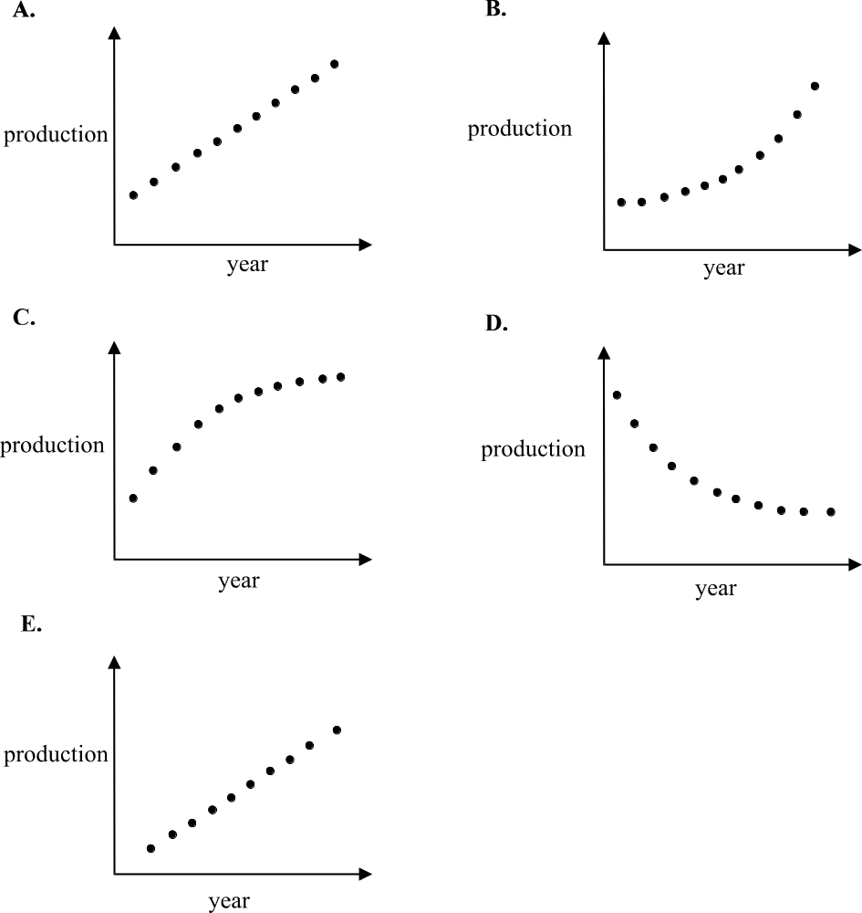

Question 8

Prue uses the following equation based on the annuities formula to calculate how long it will take to pay back her reducing balance loan of $25 000.
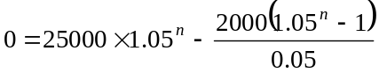
She repays $2000 each 6 months and interest is calculated at a compound rate of 5% per 6 months.
The time in years, taken for Prue to repay the loan is closest to

- 1
- 5
- 10
- 20
- 25

Question 9

A solicitor charges compound interest, calculated weekly, at the rate of 26% per annum on accounts, which have not been paid. James owed the solicitor $1200 and incurred an additional late fee charge of $86.79.
How many weeks overdue was James’ payment of his account?

- 1
- 5
- 7
- 14
- 22
Module 5: Networks and decision mathematics

If you choose this module, all questions must be answered.

Question 1

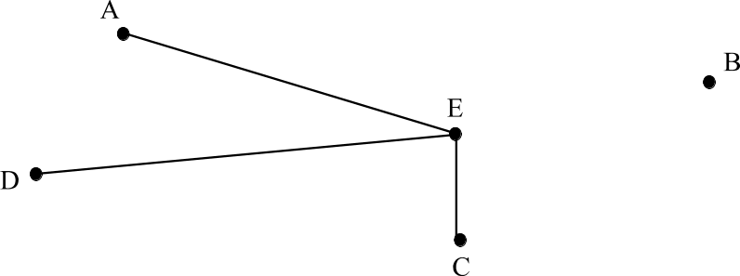

The graph above could be described as a

- complete graph
- degenerate graph
- simple graph
- digraph
- connected graph

Question 2
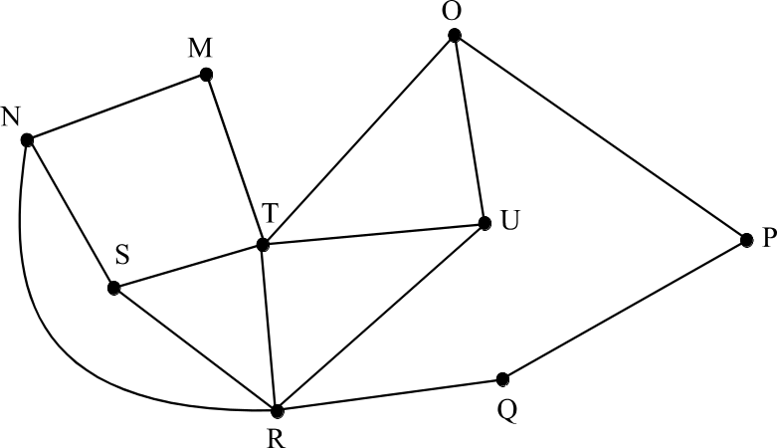

The number of vertices in the above graph, which have an even degree, is

- 1
- 2
- 3
- 4
- 6

Question 3

Which one of the following is not a planar graph?

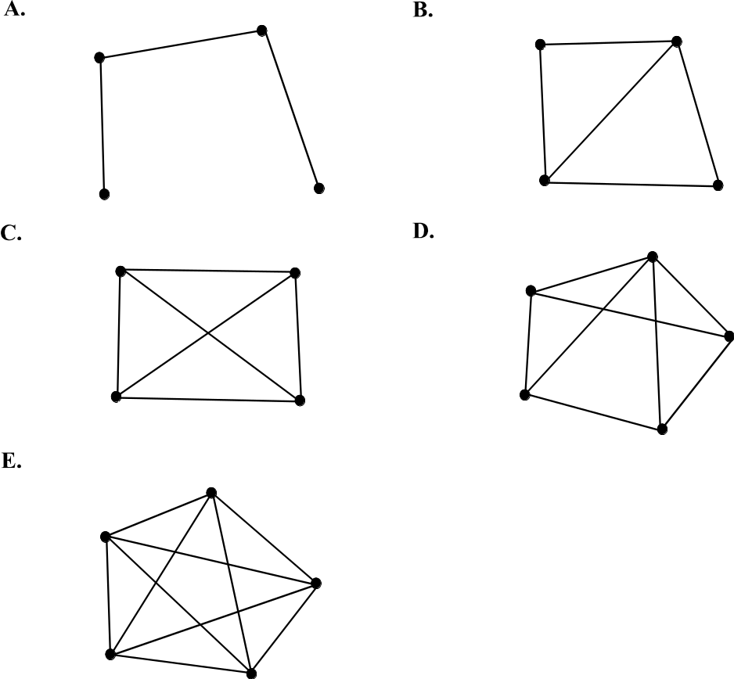

Question 4

For a connected, planar graph where v represents the number of vertices, e represents the number of edges and f represents the number of regions, which one of the following cannot be true?

- 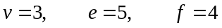
- 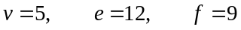
- 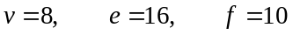
- 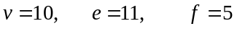
- 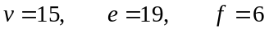

Question 5

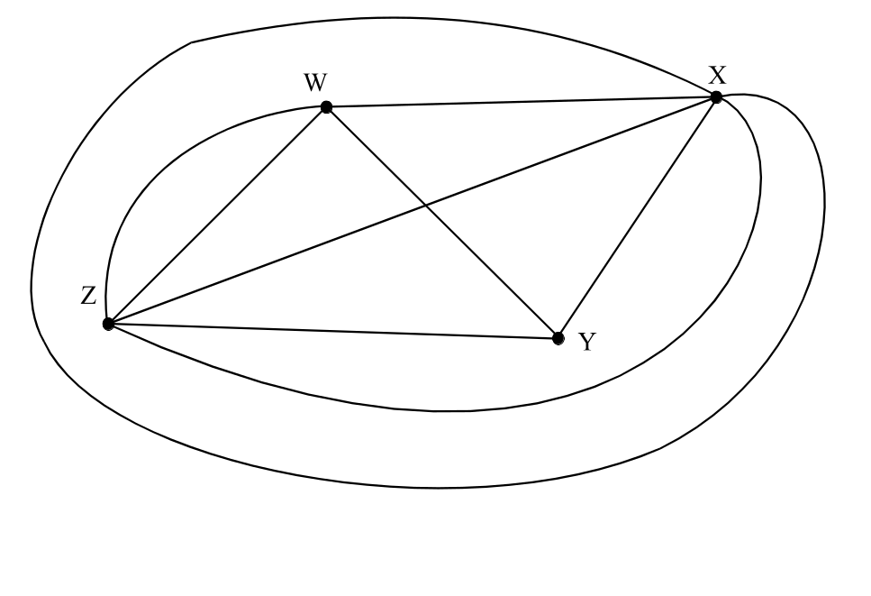

The adjacency matrix for the graph shown above is

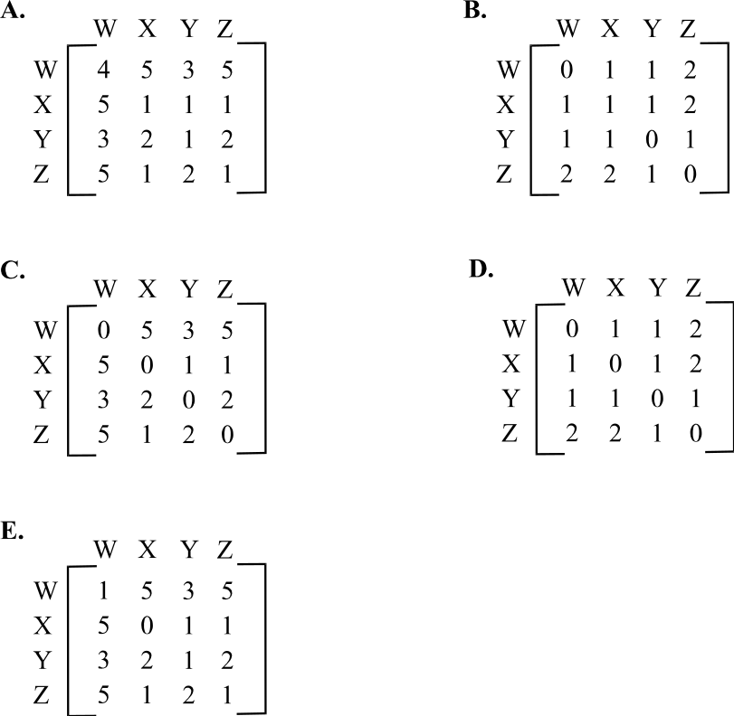

Question 6
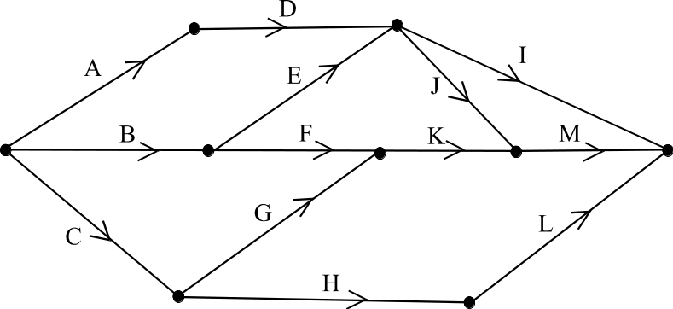

For the directed graph shown above, the immediate predecessors for each activity are correctly described by which one of the following tables?
A. B. C.
Activity | Immediate  predecessor
A | -
B | -
C | -
D | A
E | B
F | B
G | C
H | C
I | D,E
J | D,E
K | F,G
L | H
M | J,K

Activity | Immediate  predecessor
A | -
B | -
C | -
D | A
E | B
F | B
G | C
H | C
I | D
J | D
K | F,
L | H
M | K

Activity | Immediate  predecessor
A | -
B | -
C | -
D | A
E | B
F | B,E
G | C
H | C,G
I | D,E,J
J | D,E
K | F,G
L | H
M | J,K,F,G

Activity | Immediate  predecessor
A | -
B | A
C | -
D | A
E | B
F | B
G | C
H | C
I | D,E
J | D,E
K | F,G
L | H
M | J,K

Activity | Immediate  predecessor
A | -
B | -
C | A,B
D | A
E | B
F | B,E
G | C
H | C
I | D,E
J | D,E
K | F,G
L | H
M | J,K,F,G

D. E.

Question 7

An IT company rates its technician on a scale from rating 1 to rating 5 in terms of ability to solve problems in different repair areas (with rating 1 the top rating). The table below shows the ability of 4 technicians in 4 areas.

 | printers | cd writers | modems | monitors
Bill | 1 | 5 | 4 | 3
Spiro | 2 | 3 | 2 | 5
Angela | 4 | 2 | 2 | 3
Jo | 2 | 4 | 3 | 2

If the company is required to solve a problem in each of the 4 areas, which technician should be assigned to each of the 4 areas to best utilize their abilities?

- Bill to printers
Spiro to modems
Angela to cd-writers
Jo to monitors

- Bill to cd-writers
Spiro to printers
Angela to modems
Jo to monitors

- Bill to modems
Spiro to monitors
Angela to cd-writers
Jo to printers

- Bill to monitors
Spiro to printers
Angela to modems
Jo to cd-writers

- Bill to printers
Spiro to cd-writers
Angela to modems
Jo to monitors

Question 8

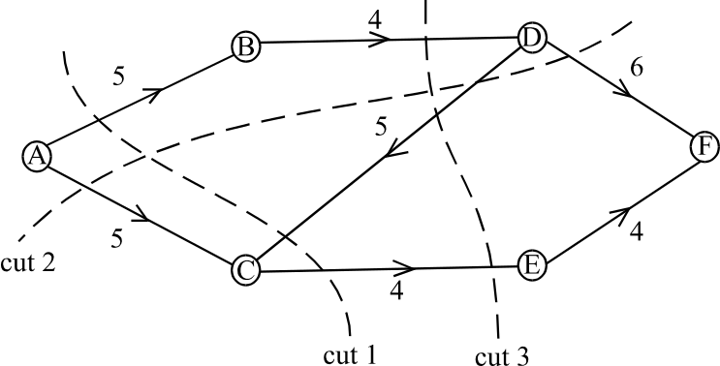

In the network shown above, the capacities are shown on each of the arcs. The maximum flow from vertex A to vertex F can be calculated using one of the three cuts shown.
The maximum flow is

- 8
- 9
- 11
- 14
- 16

Question 9
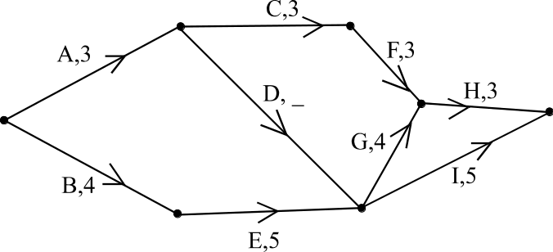

The directed graph above shows the activities necessary to complete a project. The time taken to complete the activities, in weeks is shown next to all the activities except D. The critical path for the project is A, D, G, H and the minimum time for completion of the project is 17 weeks. The time taken to complete activity D in weeks is

- 3
- 4
- 5
- 6
- 7

Further Mathematics Formulas

Business-related mathematics

simple interest: 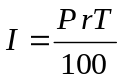
compound interest: 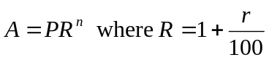
hire purchase: 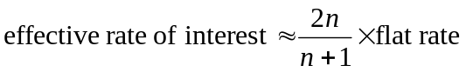
annuities: 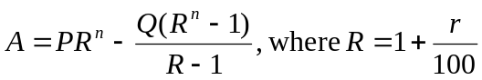

Geometry and trigonometry

area of a triangle: 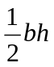
area of a triangle: 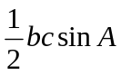
area of circle: 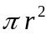
volume of sphere: 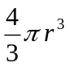
volume of cone: 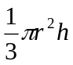
Pythagoras’ theorem 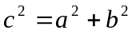
sine rule: 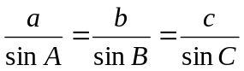
cosine rule: 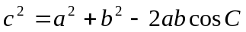

Graphs and relations

Straight line graphs

gradient: 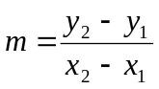
equation: 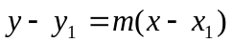 gradient-point form

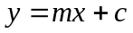 gradient-intercept form
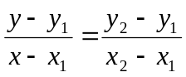 two-point form

Reproduced with permission of the Victorian Curriculum and Assessment Authority.
(These formula sheets have been copied from the 2001 Further Maths Exam 1. Teachers and students are reminded that changes made to formula sheets are notified in the VCE Bulletins and on the VCAA website.)

Number patterns and applications

arithmetic series: 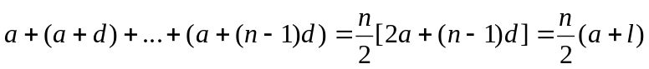
geometric series: 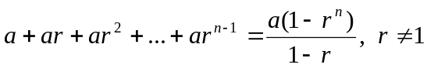
infinite geometric series: 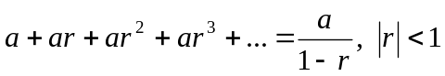
linear difference equations: 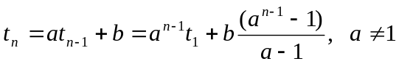
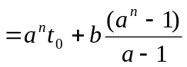

Networks and decision mathematics

Euler’s formula: 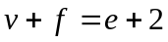

Statistics

seasonal index: 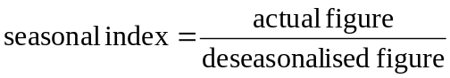

Reproduced with permission of the Victorian Curriculum and Assessment Authority.
(These formula sheets have been copied from the 2001 Further Maths Exam 1. Teachers and students are reminded that changes made to formula sheets are notified in the VCE Bulletins and on the VCAA website.)

